ECE 411 _ TEAM ASSIGNMENT #5

SYSTEM DESIGN AND MODELING FOR VACCINE MORNITORING SYSTEM

Authors: Thanh Le, Ha Tran, Daniel Diaz, Dwayne Hoeck

November 17, 2016

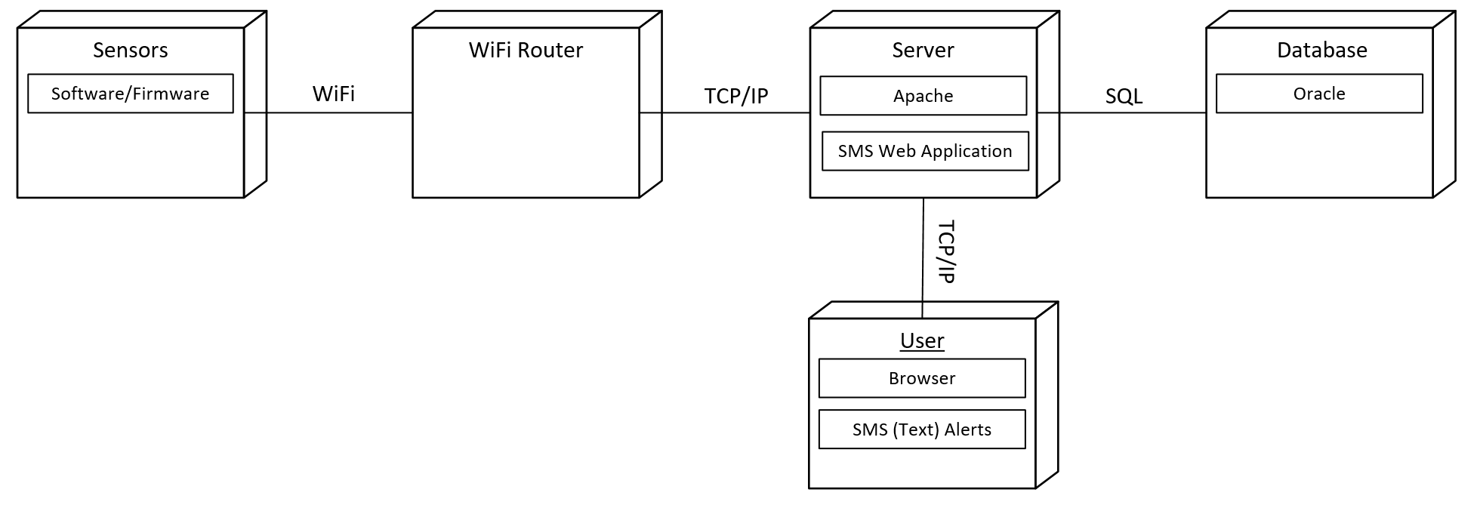

Figure 1: UML physical view of the vaccine cooler temperature sensing system

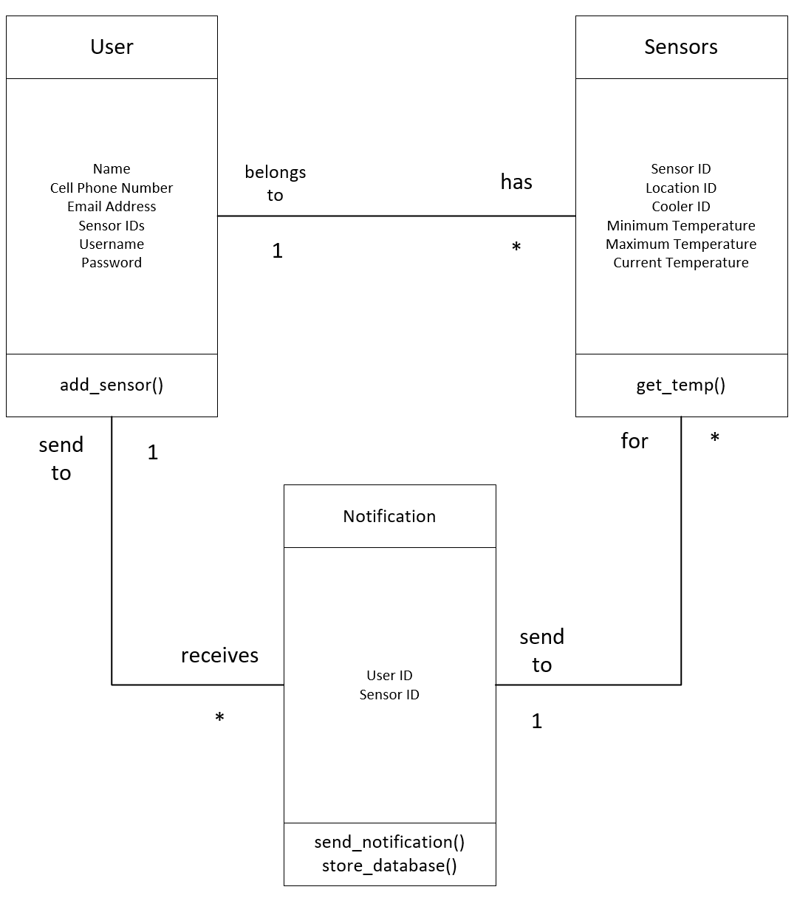

Figure 2: UML class diagram that describes the data that resides on the server

Table 1: UML use-case description for adding a vaccine temperature sensor by a user

|  |  |
| --- | --- |
| Use-case | Adding a Vaccine Temperature Sensor |
| Actors | User, WebServer, Database |
| Description | This use-case occurs when a user wants to add a new sensor to a vaccine fridge. If this is a new user, they are prompted to add their information: name, phone number and email. New and existing users are prompted to input the sensor ID from the sensor |
| Assumption | Each sensor has the sensor ID printed on the sensor, they cannot be changed. User has wifi. |
| Steps | 1. Customer signs in   If the customer is a new customer, then create a new account:   * 1. Prompt for Username   2. Validate username availability. If not available, comeback to step 1.1   3. Prompt for Password   4. Prompt for Name   5. Prompt for Cell phone number   1.6 Prompt for Email   1. Prompt for user information 2. Validate user information    1. Username and password must be both correct.    2. If either username or password is wrong, go back to step 2. 3. Prompt for SensorID 4. Validate SensorID by sending a get message on Wifi network 5. Prompt for temperature range. |
| Non-functional | *Performance***:** All members of the design team can do the process within less than 10 minutes.  *Reliability*: The user can always add a new sensor as long as the Webserver is active. |

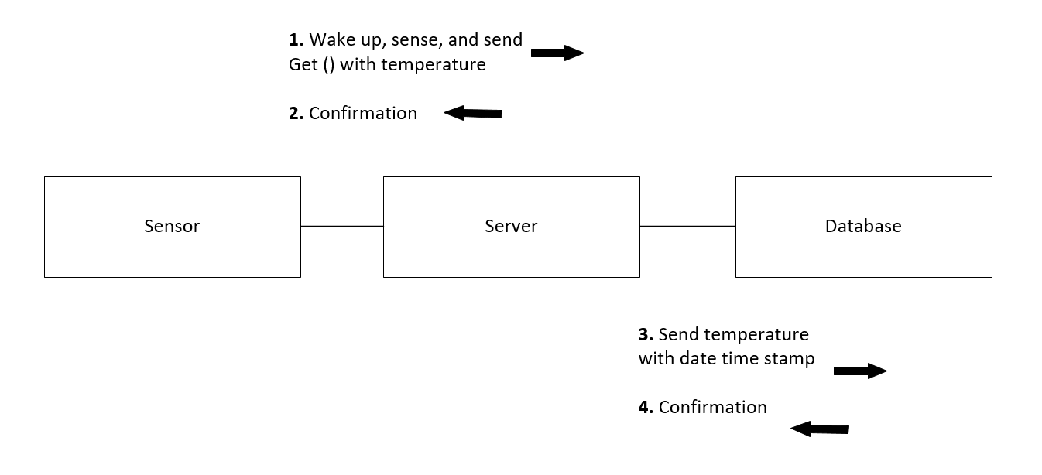

Figure 3: UML interaction view for the temperature sensor to periodically wake up, sense temperature and send to the database.

To communicate the current temperature to the server we send the following HTTP GET string. We replace sensorID with the actual number ID and temp with the actual temperature in degree Celsius. The current directory is where the sensorID and temp will be stored.

GET <http://www.awesometempsensor.com/current?sensorID&temp>

Example: to send a data set of ID = 1234 and temperature = 12 degree Celsius. Send:

GET <http://www.awesometempsensor.com/current?1234&12>